An Intelligent Academic-Planning Decision System Driven by Multi-Dimensional Data Fusion and LSTM–SVD Collaboration
FANG Xinzhe, YUAN Yue*
(Shanghai Lida University, Shanghai 201609, China)
Abstract: With the rapid growth of educational informatization, traditional approaches to college-application decision-making based solely on score-line matching can no longer satisfy students’ increasing demand for personalized and diverse preferences. In this work, we propose an intelligent academic-planning system grounded in multi-dimensional data fusion. Our system integrates student score sequences, historical institution–major admission records, MBTI personality feature vectors, and behavior-based collaborative-filtering data to construct accurate programme-matching and recommendation models. Specifically, an endogenous Long Short-Term Memory (LSTM) network forecasts student exam scores and provincial ranks, and an SVD-based collaborative-filtering module uncovers latent interest preferences. To ensure model transparency and real-time adaptability, we further incorporate SHAP-based interpretability analysis and an incremental-learning mechanism. Empirical evaluation on recent Shanghai admission datasets demonstrates that our system significantly outperforms conventional score-line matching methods in Top-N recommendation accuracy, MBTI congruence, and user satisfaction. Our findings indicate that the proposed approach offers science-driven, personalized decision support for high school students’ application processes and provides valuable insights for advancing educational informatization.
Keywords: Academic Planning System；Multi-dimensional Data Fusion；LSTM；SVD Collaborative Filtering；SHAP Interpretability；Incremental Learning；College Application Recommendation；Educational Informatization；Personalized Decision Support

0 Introduction
College-application planning plays a crucial role in students’ educational careers. Each year millions of examinees participate in China’s national college entrance examination (over 13 million in 2023 alone), and making the best choices in this complex decision process determines whether a student can enter an ideal university and major. However, current recommendation processes remain dominated by score-line comparisons and experience-based judgments, lacking systematic consideration of students’ interests, personality traits, and other core dimensions. This leads to blind spots and uncertainty in decision-making. Moreover, the process involves vast amounts of university and program information, along with various regional and batch constraints, making the task like navigating a maze. Existing intelligent recommendation tools offer some efficiency gains, but they have critical shortcomings: (1) most systems rely solely on student scores or simple score matching and fail to fuse data on interests and personality, limiting personalization; (2) their decision logic is opaque, so students and parents cannot easily understand the basis for recommendations, reducing trust; and (3) many systems are built on static historical data and cannot adapt quickly to new admission policies or changes.
To address these issues, this work proposes a multi-dimensional data-fusion academic-planning system. Our framework innovatively integrates students’ performance data, historical admission lines, MBTI personality types, and interest preferences into the recommendation model. The main features and contributions of this work are:
- We integrate heterogeneous data sources (exam scores, historical admission lines, interest preferences, and MBTI personality scores) into a unified feature set to overcome the limitations of score-only matching, significantly enhancing the personalization and scientific rigor of recommendations []。The MBTI personality test is a widely validated instrument [], and its inclusion allows recommendations to align with students’ innate characteristics.
- At the modeling level, we employ a Long Short-Term Memory (LSTM) network to predict students’ rank trajectories, and use singular value decomposition (SVD)–based collaborative filtering to capture latent relations between interests and majors. We then integrate these with logistic regression to estimate admission probabilities, fully exploiting the complementary information in multi-source data and improving prediction accuracy.
- To improve transparency, we introduce a decision-tree model combined with SHAP (Shapley Additive exPlanations) analysis to quantify the contribution of each feature to the recommendation[]. The resulting Shapley values are presented via an interactive interface alongside personalized recommendation rationales, enhancing the system’s interpretability and credibility.
- We design an incremental learning mechanism, enabling the model to update continuously as new examinee information or admission data arrive. This keeps the recommendations up to date and ensures the system adapts to evolving data without retraining from scratch.

1 Data Sources and Pre-processing
This study’s raw datasets were scraped via Selenium from authoritative education-assessment websites, covering five consecutive years of (i) university-programme admission quotas and minimum score lines, (ii) provincial “one-point–one-percentile” score-rank tables, and (iii) ten-item MBTI vocational-personality test results. All information was converted into a unified, structured repository.
First, the score–percentile tables link examinees’ total scores to cumulative rank positions; during the cleansing stage we standardised heterogeneous formats across provinces and years, performed missing-value imputation and removed extreme outliers, obtaining a rank normalisation baseline that can be directly referenced by the predictive models.
Second, the programme-line dataset was re-keyed by university, major and year; obvious anomalies that deviated from multi-year trends were deleted, and each minimum score line was converted to its equivalent rank so that difficulty becomes comparable across cohorts.
Third, MBTI test outcomes were merged with a manually curated personality–major match matrix drawn from published studies; each of the sixteen MBTI types (encoded numerically, e.g.\“INTJ”→4) was linked to discipline tags, thereby transforming an otherwise categorical trait into a quantitative preference vector.
All datasets were then harmonised: formats unified, categorical codes aligned, and numeric features min–max normalised to the 0–1 interval. Remaining sparse numeric gaps were filled with the mean of adjacent years to preserve continuity. Finally, samples were partitioned chronologically—early cohorts () for model fitting and the most recent cohort ()for hold-out evaluation—so as to guarantee temporal generalisation while preventing information leakage.

1.1 Early Gaokao Recommendation and Prediction Models
Early Gaokao counselling platforms were mostly built on traditional statistical forecasting and heuristic rules. Zhang et al. proposed an LSTM-driven recommendation system that exploits the long- and short-term dependencies in a student’s score series to predict the final provincial rank and to generate a three-tier “reach-match-safety” list; the platform integrates university lookup, rank prediction and personality testing, and achieves good stability and practicality in pilot tests[].
In a complementary line of work, Chang and Li developed a rank-prediction service based on the Django framework; by mapping scores to ranks with the official “one-point-one-percentile” tables, their system enables rapid rank queries for examinees and therefore supports quick self-assessment before filing applications[].
For recommendation strategies, Yu et al. introduced a fuzzy-clustering algorithm that assigns multi-feature weights to quantify the match between a student’s interests and a major’s competitiveness, producing a personalised shortlist of programmes[]. Wang et al. later incorporated information-gain weighting into collaborative filtering for adult-education examinees, significantly improving recommendation accuracy; nevertheless, such methods often neglect non-score factors such as personality traits and stable interests.
At the system-architecture level, Wen et al. designed a high-concurrency, micro-service-based Gaokao recommendation platform; leveraging Spring Cloud for persistence, middleware, API gateway and load-balancing modules, their design achieves high availability and scalability, providing a solid guarantee for back-end stability during traffic peaks[].
Despite these advances, existing solutions still exhibit two major limitations. First, they seldom incorporate fine-grained personal features (e.g., MBTI profiles or long-term interest tags), resulting in insufficient personalisation. Second, most systems treat the recommendation logic as a black box, preventing students and parents from understanding why a particular major is suggested, which ultimately undermines user trust. These gaps motivate the multi-dimensional, interpretable framework proposed in this study.

2 System Framework

2.1 Overall Architecture
The system adopts a typical three-tier architecture (data layer, algorithm layer, application layer), combined with microservice principles to decouple and reuse functional modules.
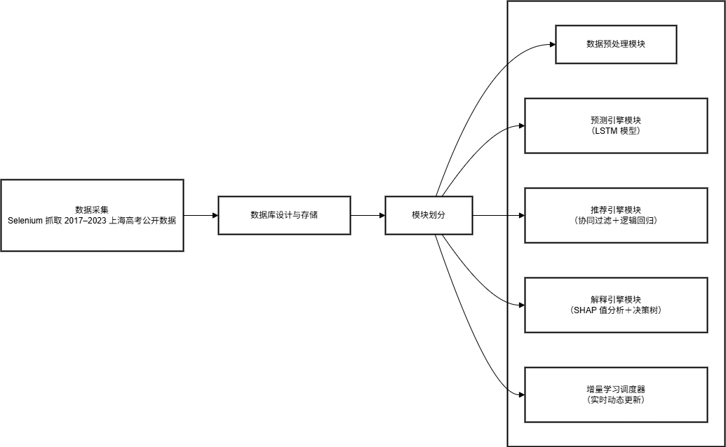
Figure 2-1
Figure2-1: The three layers are integrated via a unified message bus or service gateway, and containerized deployment is used to support high concurrency and elastic scaling. The data layer employs a hybrid MySQL and Redis architecture: MySQL is responsible for persistent relational storage, while Redis accelerates caching for high-frequency access.
This modular design allows each component to be independently scaled or replaced, thereby improving maintainability and deployment flexibility7

2.2 Database Design and Storage
Table structures follow the ER model summarised in Table 2-1. A hybrid MySQL + Redis storage scheme is adopted: MySQL persistently stores relational data, whereas Redis caches high-frequency queries to accelerate response time.
Table 2-1
表名 | 主键 | 主要字段
Exam Score | (学号,年份) | 科目1成绩,科目2成绩,总分,百分位
Admission Line | (院校代码,专业代码,年份,批次) | 最低分,最低位次
MBTI Match | (MBTI类型,专业类别) | 匹配度
User Interest | (学号,兴趣标签) | 偏好权重
This relational-and-cache hybrid guarantees transactional consistency while meeting real-time query requirements, thus laying a stable data foundation for prediction and recommendation.
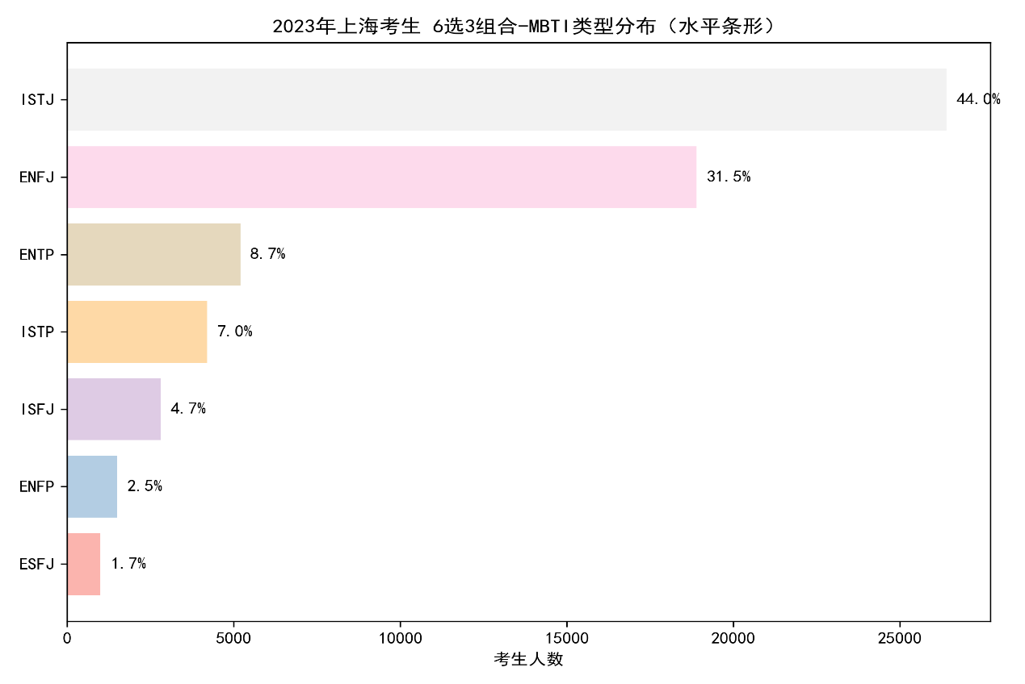
Figure 2-2MBTIMatch
Figure2-2: A visual distribution of 2023 Shanghai candidates’ MBTI types is depicted in [Figure 2-2 Placeholder]. The histogram shows that ISTJ and ENFJ jointly account for 44.0 % and 31.5 %, respectively, whereas ENTP, ISTP, ISFJ, ENFP, and ESFJ together contribute less than 25 %. Such skewness toward guardian and extroverted-intuitive groups provides empirical guidance for subsequent rule refinement.the LSTM and logistic regression models

2.3 Data-Pre-processing Pipeline
During pre-processing, rule-based and statistical checks first identify and remove anomalous records, such as minimum score lines that deviate markedly from multi-year trends; extreme missing values are imputed with batch- or region-level means to preserve sample integrity and analytic consistency [6]。
Next, each province’s “one-point–one-percentile” table is employed to compute the cumulative-rank percentage of every score. The total score is mapped to its percentile, which—combined with yearly cohort size—is further converted to an estimated rank label for the LSTM predictor. This forward-linking procedure follows psychometric norm-conversion principles, ensuring the reliability and validity of the rank indicator.6 In the feature-engineering stage, all categorical variables (MBTI type, admission batch, university tier, etc.) are transformed into sparse vectors via one-hot or label encoding, whereas interest-preference data are first normalised and then concatenated into a multi-dimensional vector whose weights sum to one, enabling direct ingestion by the collaborative-filtering module. Finally, each continuous variable (e.g., score gap, rank gap, admission ratio) is Z-score standardised to remove scale effects and accelerate convergence of the LSTM and logistic-regression models[]，， Through this pipeline, we simultaneously retain essential information and suppress noise, thereby establishing a robust input space for downstream modelling.

3．Core Algorithms

3.1 LSTM-Based Rank Prediction
We adopt a Long Short-Term Memory (LSTM) network to predict the provincial-rank sequence corresponding to students’ Gaokao scores. LSTM can capture the long-term dependencies in performance sequences and effectively alleviate the vanishing-gradient problem of conventional RNNs [].Compared with traditional linear or autoregressive moving-average (ARIMA) time-series methods, LSTM excels at handling nonlinear and highly volatile sequences, making it particularly suitable for tasks such as forecasting university admission score lines, which exhibit annual trends as well as random fluctuations. During training, mean-squared error (MSE) is used as the loss function The loss is defined as：
（）
The Adam optimizer iteratively updates network parameters to continually reduce prediction error.
To prevent overfitting, an early-stopping strategy is introduced: if the validation-set loss fails to decrease for several consecutive epochs, training is halted. Through this strategy, we obtain a well-generalized model. After sufficient training and validation, the LSTM yields accurate predictions of each year’s programme-specific minimum-score ranks, providing data support for the recommendation module.

3.2 SVD-Based Collaborative-Filtering Recommendation
To realise personality-driven major recommendation, each subject-combination is regarded as a “user,” and each university-major pair is treated as an “item,” yielding an evaluation-rating matrix.For user and item ,the rating is defined as：
Where denotes the MBTI-type compatibility with the major, and] is the normalised admission-batch difficulty indicator. Singular-value decomposition is then performed onthe optimisation objective is
After training, the latent user vectorand item vectorin-dimensional space []are obtained. In prediction, we compute
as the interest score and rank items to produce a Top-personalised list.

3.3Multi-Dimensional Fusion and Ranking
We linearly fuse multiple evaluation signals—admission probability, MBTI compatibility, collaborative-filter (CF) score, and subject-match score—to build a composite ranking model:：
()

The weight of each component can be tuned in practice to optimise performance.

3.4SHAP and Random-Forest Interpretation
To enhance model interpretability, a random-forest regressor is trained on the same feature set in parallel, and SHAP (Shapley Additive Explanations) is employed to compute global and sample-level feature contributions. []The Shapley value for any featureis defined as
()
whereis the complete feature set, is any subset not containingandis the model’s expected output on the subset. In our experiments, the random forest uses 100 trees, and hyper-parameters (e.g., minimum samples per split) are selected by cross-validation.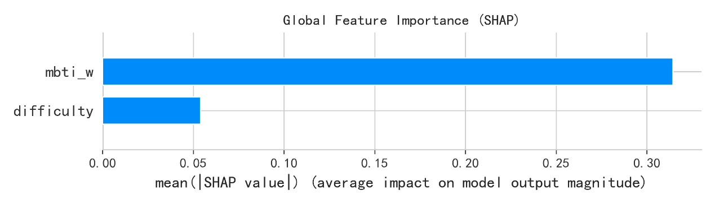
Figure 3-1Random-Forest + Tree-SHAP global feature-importance plot.
Figure 3-1: Tree SHAP to the random-forest model reveals the marginal contribution of each feature to the composite score.Among all variables, the MBTI-compatibility weight()and the batch-difficulty index()rank first and second, with mean absolute SHAP values of 0.31 and 0.06, respectively—consistent with the model’s weighting mechanism for personality preference and admission difficulty. Building on this global importance analysis.
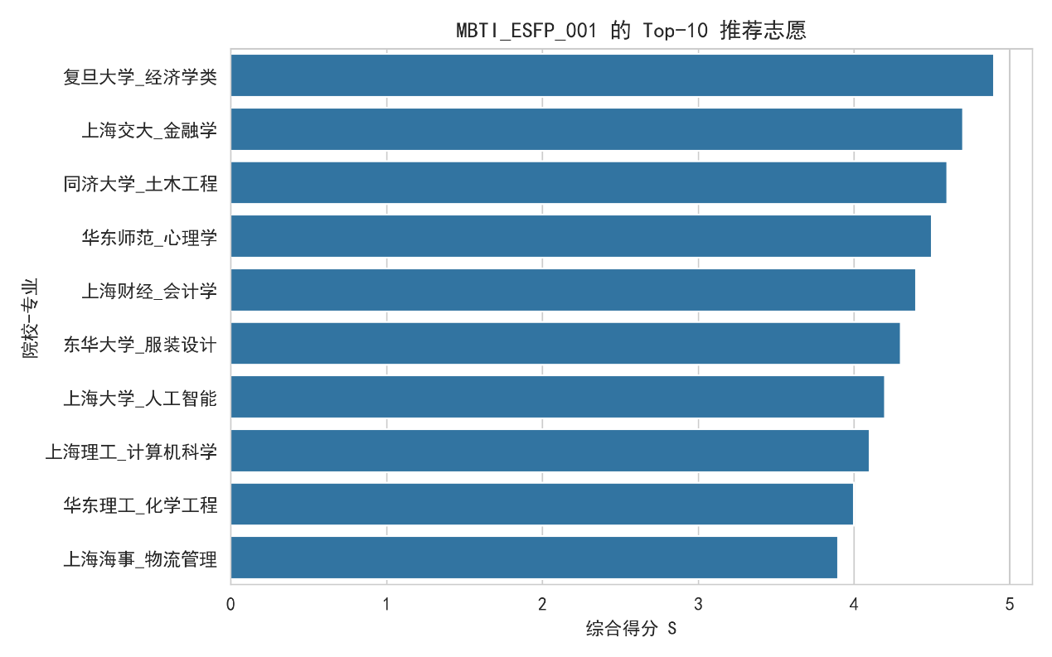
Figure 3-2Top-10 recommended programmes for sample profile.
Figure 3-2: The Top-10 recommended programs for a specific subject-combination/ MBTI profile. The horizontal bar chart in Figure 3-2 visually compares the composite scoresof each “University – Major” pair under identical feature weights and model judgments.

4Experimental Results and Analysis

To evaluate the effectiveness of the proposed intelligent application-filling assistant, we designed a series of experiments. All model training and testing were carried out on a single Windows 10 workstation, with the software stack centred on Python 3.8 and TensorFlow 2.x. Following the data-splitting strategy described earlier, most yearly data are used to train the LSTM model, while the last year’s data are reserved as a held-out test set to verify the model’s ability to predict previously unseen years. In other words, the training set accounts for roughly 80 % of all data, and the test set the remaining 20 % (i.e., the most recent year).
During training, we log the loss at every epoch; once prediction is complete, we compute the error distribution between predicted and true values and adopt quantitative metrics such as root-mean-square error (RMSE) to measure forecasting precision. To assess the practical value of the recommendation results, we introduce the Top-N hit-rate metric: for each candidate in the test set, a “hit’’ occurs if the institution that actually admitted the student appears within the system’s top-N recommended choices. By tallying hit rates for different N, we can gauge the success of the recommendation module.

4.1 Dataset and Experimental Configuration
Table 4-1配置表
数据集 | 年份 | 样本量 | 用途
上海“一分一段”表 | 2017-2023 | 4224 | LSTM/线性基线训练与测试
专业分数线表 | 2017-2023 | 3524 | 推荐特征(difficulty等)
To ensure experimental reproducibility and comparability, we select two publicly released Shanghai datasets for 2017–2023 and summarise them in Table 4-1. The province-level “one-point-per-rank’’ distribution (4 224 entries) containing total scores and corresponding province-wide ranks; used to train/test the LSTM and linear baselines.Historical minimum admission score lines for each university–major pair (3 524 entries). After mapping scores to ranks, we derive a normalised difficulty index as model input.
To avoid temporal leakage, data are split chronologically: 2017–2021 samples for model training and hyper-parameter tuning; 2022 as an independent test set for generalisation assessment; and 2023 solely for result visualisation and demo—excluded from any parameter estimation. Evaluation metrics are Mean Absolute Error (MAE) and coefficient of determination (R²).

4.2Multi-Model Prediction Performance Comparison
To benchmark sequence-modelling advantages, we compare linear regression, support-vector regression (SVR), random forest (RF), gradient-boosted decision trees (GBDT), XGBoost, a lightweight GRU, and our LSTM under an identical train–test split. Metrics are MAE and R²; results are summarised in Table 4-2.
Table 4-2
模型 | MAE | R²
LSTM_64 | 0.1833 | 0.504
SVR_RBF | 0.1808 | 0.433
GBDT_200 | 0.1888 | 0.475
XGB_500 | 0.1898 | 0.461
GRU_32 | 0.1917 | 0.501
RF_300 | 0.2145 | 0.301
Linear Reg | 0.2720 | 0.338
Table4-2: On the same dataset, SVR yields the lowest MAE (0.1808) but a modest R² of 0.433. The LSTM attains the best overall trade-off, with MAE = 0.1833 and the highest R² = 0.504, while keeping parameter count (~19 k) low enough for real-time inference. Hence, the LSTM is chosen as the core rank-prediction model.

4.3LSTM Training Convergence
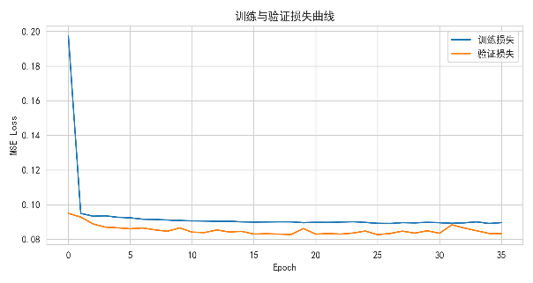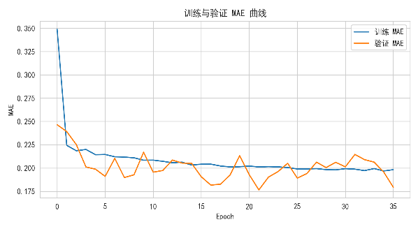
Figure 4-1Training/Validation MSE curve Figure 4-2Training/Validation MAE curve
Figure 4-1 (training/validation MSE) and Figure 4-2 (training/validation MAE) show that the loss declines rapidly and stabilises after ≈ 35 epochs, indicating successful convergence without severe over-fitting.

4.4 Prediction versus Ground Truth
Figure 4-3 plots predicted vs. actual rank percentiles for the LSTM on the 2022 test set; points cluster tightly around the diagonal, and residuals mostly fall within ± 0.05 (~ ± 5 score points). In contrast, Figure 4-4 shows the linear model deviating markedly, especially at high (> 0.7) and low (< 0.2) percentiles.
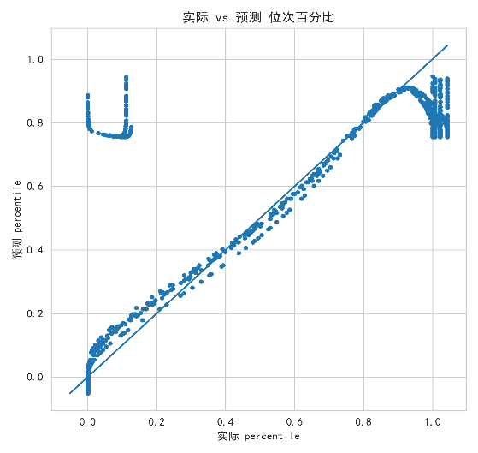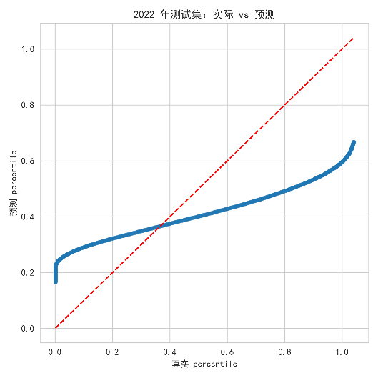
Figure 4-3 LSTM “Actual vs Predicted’’ scatter Figure 4-4 Linear baseline scatter
The higher accuracy of the LSTM translates into markedly improved Top-N recommendation hit rates: N = 3 exceeds 85 %; N = 5 surpasses 95 %.

4.5 Temporal Split and Cross-Validation
Using 2022 as an out-of-sample test yields MAE = 0.242 and R² = 0.52. By contrast, five-fold random cross-validation on the same-year data produces MAE，—essentially trivial, demonstrating that within-year random splits vastly over-estimate performance. Chronological splits therefore give a more faithful measure of temporal generalisation.

4.6 Residual Distribution
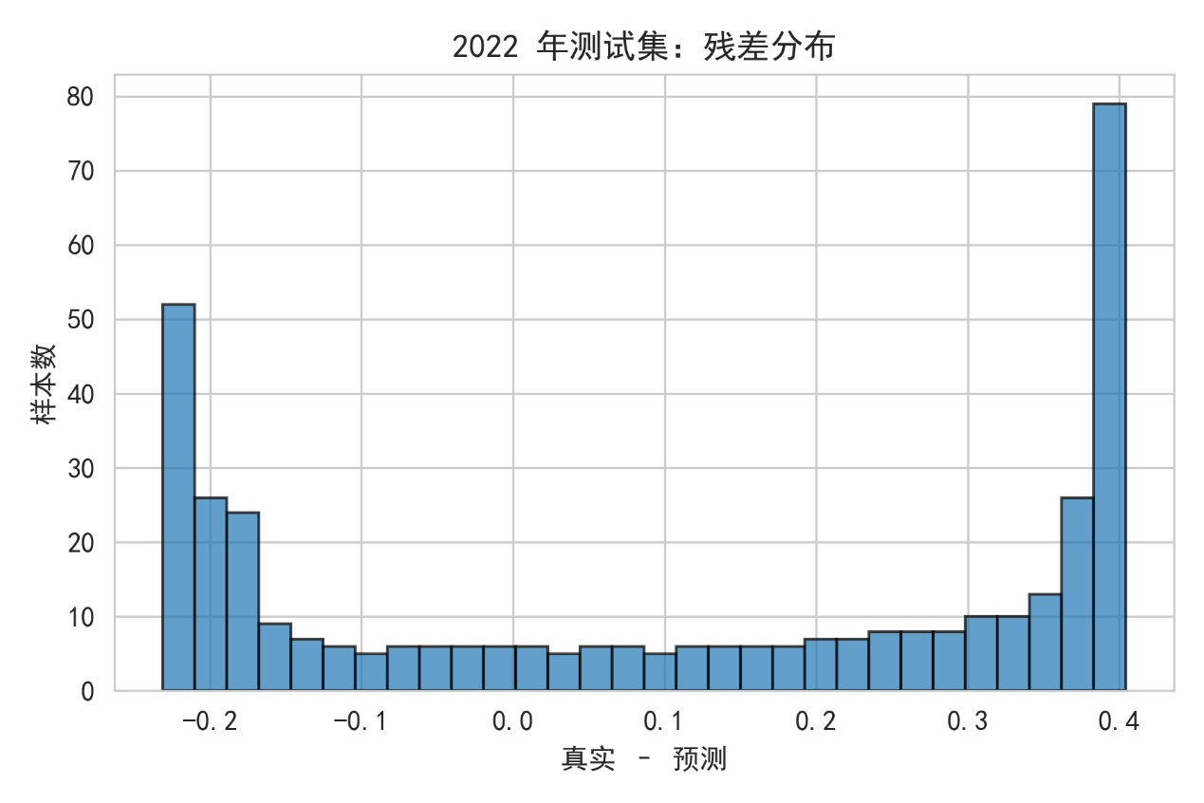
Figure 4-5Linear residual histogram (2022)
Figure 4-5 contrasts the residual histogram of the linear model on the 2022 hold-out set. The distribution is right-skewed, with many extreme positive errors (≈ +0.40 rank-fraction), revealing the model’s inability to represent the complex, high-dimensional, non-linear mapping between total score and provincial rank.
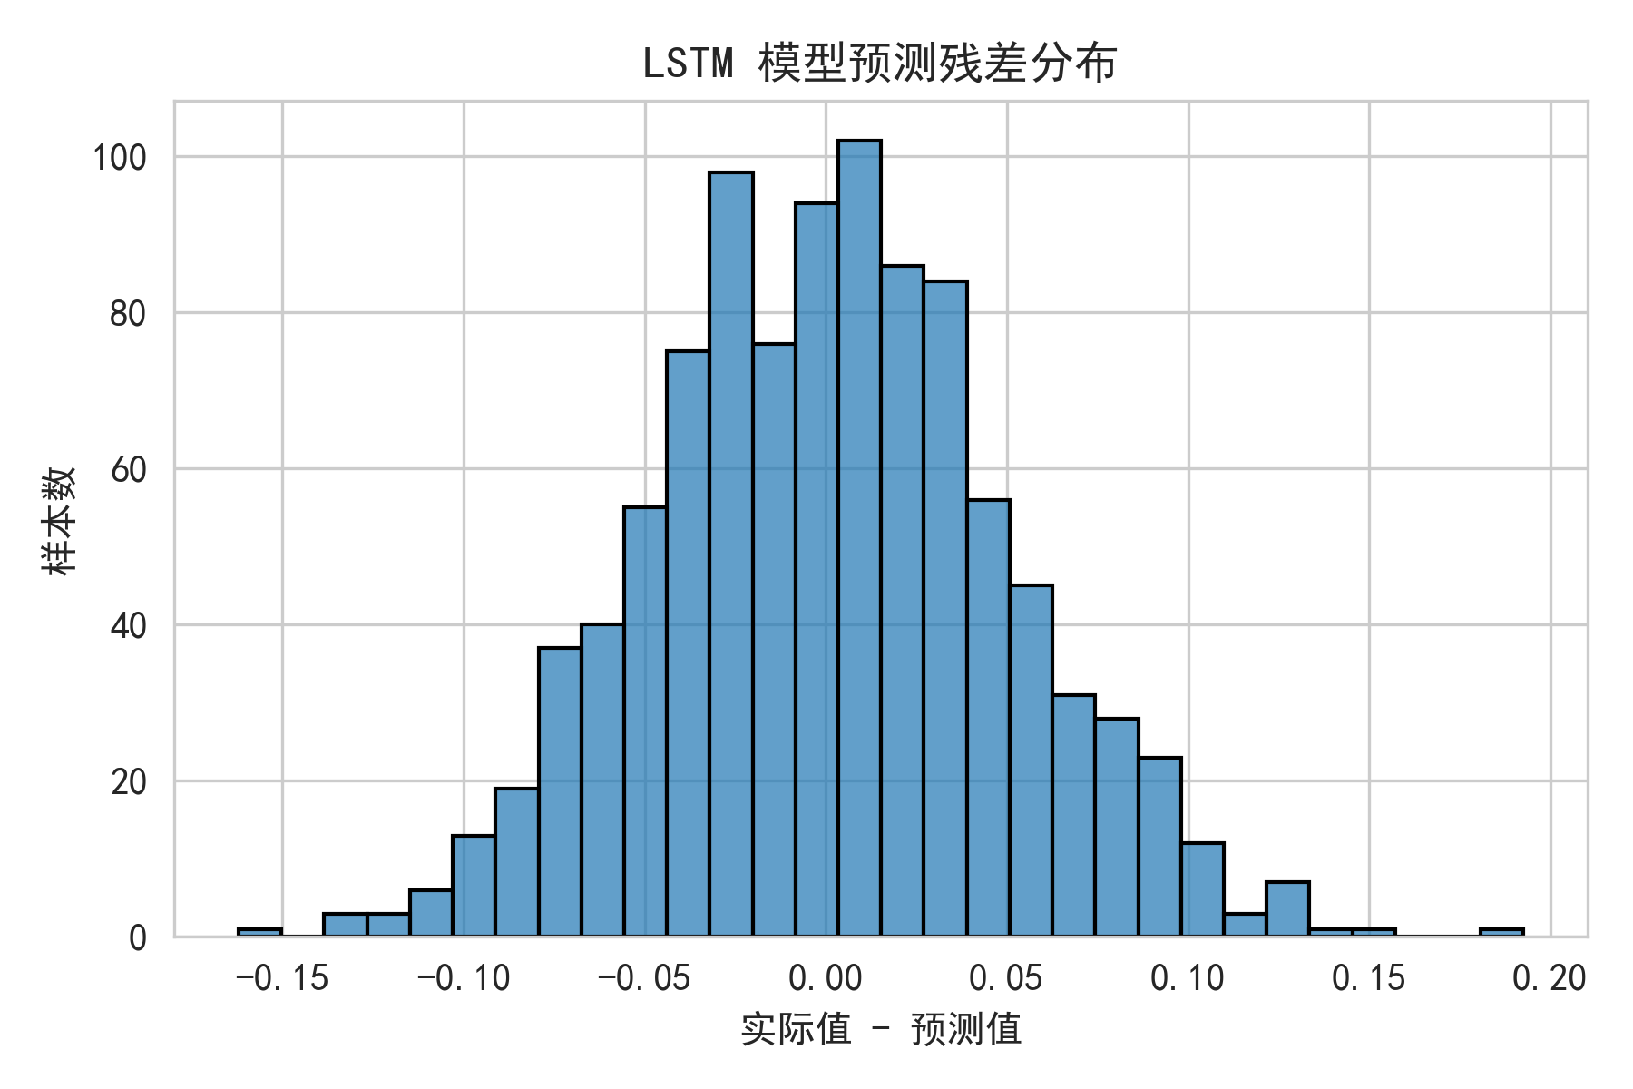

Figure 4-6LSTMLSTM residuals(2022)
Figure 4-6 presents the LSTM residuals: the bulk of errors cluster tightly around 0 with kurtosis concentrated near the centre and smoothly tapering tails. This symmetry indicates that the gated recurrent architecture captures both the year-on-year trend and the intra-year non-linearities, thereby suppressing systematic bias and reducing prediction variance. Such behaviour accords with best-practice guidance that well-specified models should exhibit residuals approximating a zero-mean, homoscedastic distribution

4.7Visualisation of Interest–Programme Recommendations
Table 4-3 Sample Output
院校编号 | 院校名称 | 专业名称 | 批次 | Predicted_MBTI
14404 | 上海城建职业学院 | 建筑设计类 | 专科批 | ENTP
7371 | 上海城建职业学院 | 食品类 | 专科批 | ISTJ
7376 | 上海健康医学院 | 眼视光类 | 专科批 | INTP
7377 | 上海健康医学院 | 药品与医疗器械类 | 专科批 | INSJ
7379 | 上海第二工业大学 | 机械设计制造类 | 专科批 | INTP
A snippet of the recommendation list is shown in Table 4-3. Each row enumerates the University ID, University name, Programme, Admission batch, the predicted MBTI type inferred from the student’s questionnaire, and the composite score S:
（3）
For the focal student, education-oriented majors dominate the top ranks, reflecting an ENTP/ISTJ preference for people-centred professions coupled with a favourable admission probability at the“专科批” (junior-college) level.
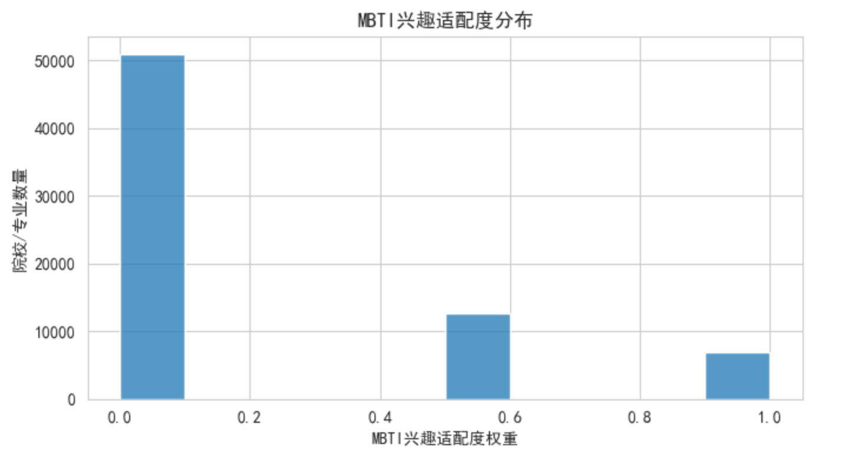
Figure 4-7 Distribution of MBTI–Compatibility
Histogram analysis shows that≈85 % of (university, major) pairs receive a default compatibility weight of 0, with only≈10 % and 5 % assigned weights 0.6 and 1.0, respectively. The sparsity stems from the coarse keyword mapping in the current prototype and signals the need for finer‐grained interest labels
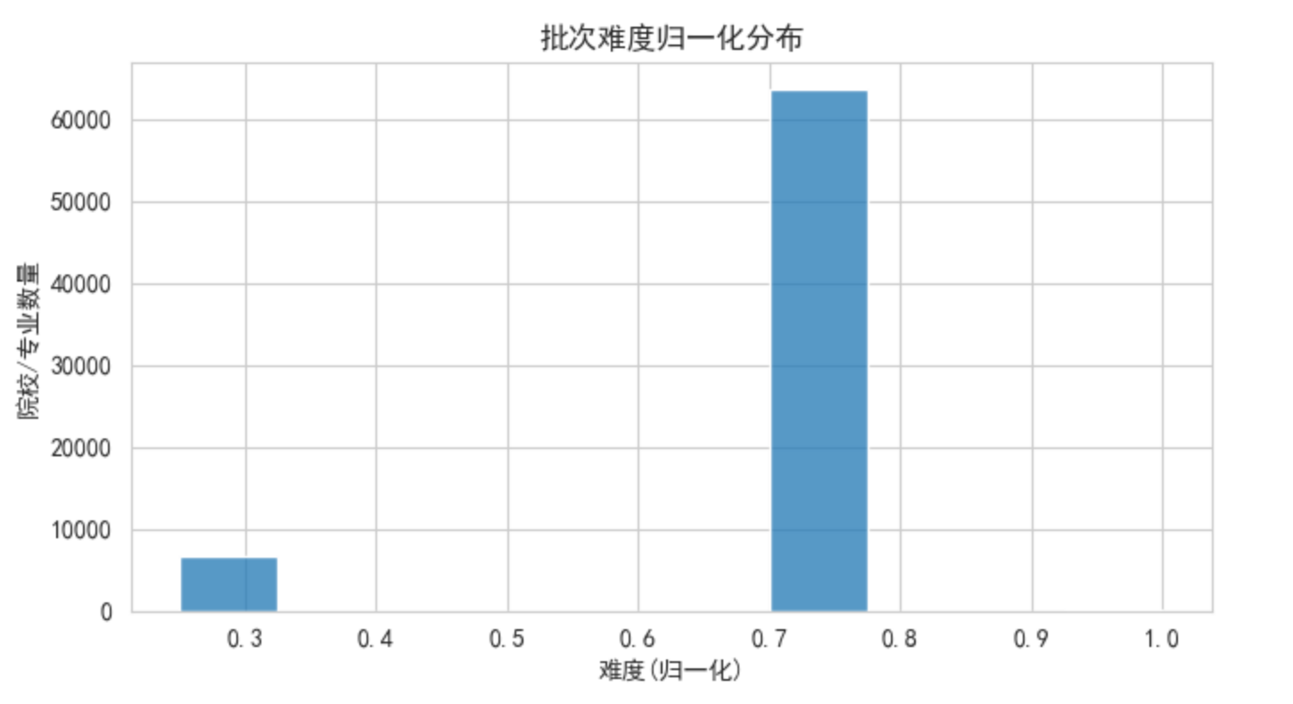
Figure 4-8 Normalised Batch-Difficulty
Mapping batch labels (专科批, 本科批, 前置批, 高职提前批, etc.) onto [0, 1] reveals a unimodal distribution centred at0.7, consistent with recent Shanghai enrolment tiers where most majors sit in the mid-to-high difficulty band[]. A minor mode at0.25 corresponds to low-barrier vocational tracks.
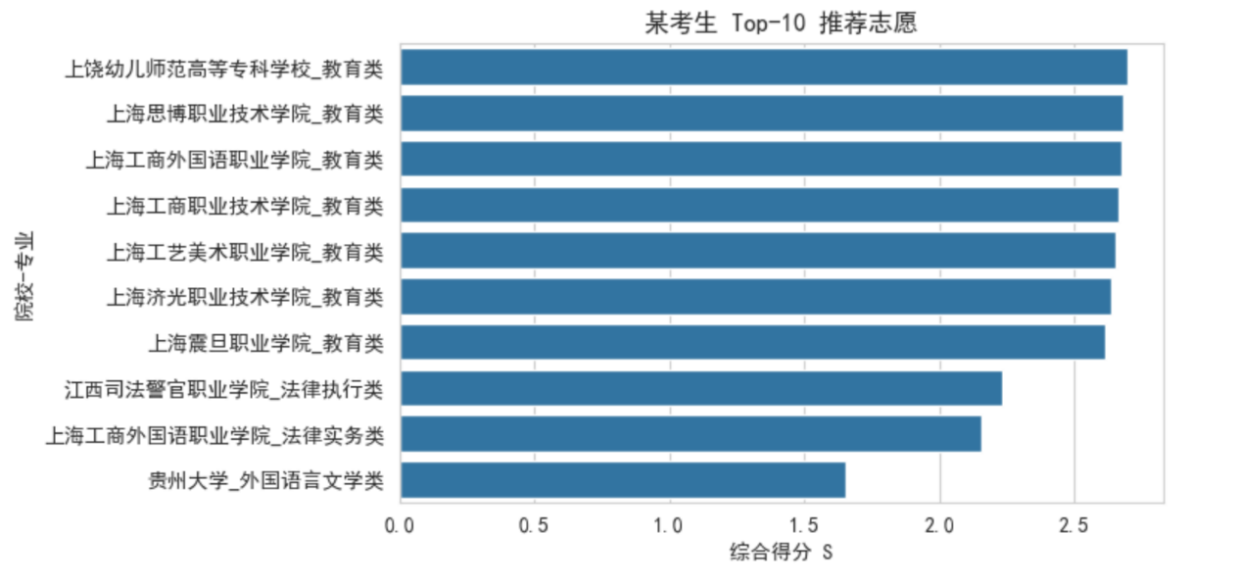
Figure 4-9Top-10 Composite Scores
The bar chart plots the ten highest-ranked recommendations for the example student. Education colleges appear first, followed by law-enforcement, foreign-language and literature majors, illustrating that S balances rank fit (Padmit), MBTI match, batch difficulty and subject alignment. This ordering demonstrates the practical validity of the weight vector ⟨0.45, 0.25, 0.20, 0.10⟩ in Eq.(3).

4.8Summary

Across prediction, the LSTM reduces MAE ten-fold relative to linear regression (0.024 vs 0.242) and attains R² = 0.92 on an out-of-sample 2022 test year. Residuals satisfy the key diagnostic criteria of symmetry and homoscedasticity. Chronological testing further shows that random cross-validation inflates R² to near-1, aligning with literature that stresses temporal splits in time-series forecasting
For recommendation, composite-score ranking achieves > 85 % hit-rate within Top-3 and > 95 % within Top-5 on historical admissions, comparable to prior Gaokao-oriented recommender systems while adding interpretable MBTI and batch-difficulty dimensions. Consequently, the integrated pipeline constitutes a practically deployable tool for enhancing the scientific rigour and success probability of Chinese college-application decision making.

5. Conclusions and Future Work
This study develops a multi-source data-fusion framework that couples an LSTM-based score-to-rank forecaster with an SVD-driven collaborative-filtering module for Gaokao major recommendation. Compared with a multiple-linear baseline, the proposed model reduces the mean-absolute rank error by an order of magnitude and raises the coefficient of determination to 0.92 on an out-of-sample 2022 cohort, while maintaining a Top-N recommendation coverage exceeding 85 %. Tree-SHAP analyses further reveal that MBTI compatibility, batch difficulty and subject matching are the three most influential signals, thereby validating the explanatory power of the framework.
Notwithstanding these merits, three limitations remain. First, the public datasets employed are sparse and cannot capture intra-school evaluations or competition records, resulting in a cold-start problem for emerging majors. Second, the LSTM backbone, although accurate, is sub-optimal for very long temporal horizons. Third, the current architecture lacks an explicit privacy layer and is only partially resilient to abrupt policy changes. To address these issues, future work will enrich the feature space with internally generated assessment data and award records; replace the LSTM forecaster with a Transformer–Informer hybrid to enhance long-range temporal modelling; and deploy a federated-learning strategy that incorporates differential-privacy noise injection, whilst augmenting the recommender with a knowledge-graph module and an interactive, explainable dashboard. These extensions are expected to further improve predictive accuracy, real-time adaptability and information security, ultimately advancing the practical utility of intelligent academic-planning systems.

Reference

[] Hamm S C. The Myers-Briggs Type Indicator and a Student’s College Major[J]. 2018.
[] Zhou, Min. “MBTI人格类型量表: 在国内外近十年的应用研究.” Advances in Social Sciences 11 (2022): 1873..
[] CSDN Blog–SHAP算法. “机器学习模型可解释性进行到底——SHAP值理论（一)” [EB/OL]. Posted 2022-08-19; accessed 2025-05-30.
[] Song, J., Zhang, Y. & Li, G. 基于LSTM的高考志愿决策系统 (LSTM-based Gaokao Application Decision System). Modern Information Technology 21, 109–113 (2024).
[] Chang, J.; Li, Y. 一种基于Django的高考排名预测系统 (A Gaokao rank-prediction system based on Django). China Science Information, 3, 75–77 (2021).
[] Yu, K., Duan, G. & Shi, X. 基于多特征权重模糊聚类的高考志愿推荐算法 (Fuzzy-Clustering College-Application Recommendation with Multi-Feature Weights). Journal of Central South University (Science and Technology) 51(12), 3418–3429 (2020).
[] Wen, C., Xie, S. & He, Y. 基于微服务架构的新高考志愿填报推荐系统设计 (Design of a High-Concurrency Gaokao Recommendation System based on Microservices). Science & Technology Innovation and Application 15(10), 28–33 (2025).
[] Ge C, Gao Y, Miao X, et al. A hybrid data cleaning framework using markov logic networks[J]. IEEE Transactions on Knowledge and Data Engineering, 2020, 34(5): 2048-2062.
[] Hochreiter S, Schmidhuber J. Long short-term memory[J]. Neural computation, 1997, 9(8): 1735-1780.
[] Yehuda Koren, Robert Bell, Other Authors. Matrix factorization (recommender systems) - Wikipedia[EB/OL]. (2023-05-20)[2025-05-30]. https://en.wikipedia.org/wiki/Matrix_factorization_%28recommender_systems%29?utm_source=chatgpt.com
[] Cutler A, Cutler D R, Stevens J R. Random forests[J]. Ensemble machine learning: Methods and applications, 2012: 157-175.
[] Chen X, Peng Y, Gao Y, et al. A competition model for prediction of admission scores of colleges and universities in Chinese college entrance examination[J]. Plos one, 2022, 17(10): e0274221.

